Overview

SharePoint Patterns and Practices (PnP) contains a library of PowerShell commands (PnP PowerShell) that allows you to perform complex provisioning and artifact management actions towards SharePoint.

**What is PnP?**

Patterns and Practices where Microsoft and external members contribute to the implementation practices for SharePoint. PnP libraries are created to serve the needs of developers for easy learning and implementation of logic through client-side programming.

**Why we need PnP PowerShell?**

PnP PowerShell internally implements Client-Side Object model for its operations. This, in turn, makes the operations adaptable. The same set of operations can be executed on any SharePoint environment. Using PnP PowerShell, the single line of code is used to access any object on SharePoint, where in with traditional client side or server-side object model, multiple lines of code are required to access the objects. The code complexity reduces through this implementation.

**Requirements**

**Windows 10**, or if you have **PowerShellGet** installed

Install PnP Cmdlets

There are 3 ways to install the cmdlets.

1.    Install them from the **PowerShell Gallery**.

2.    Download the setup files

3.    Run a PowerShell script to download the **PowerShellGet** module and install the cmdlets subsequently.

**Note** - the Preferred way is to Install them from the **PowerShell Gallery**

**Command to Install**

Run the following commands to install the desired PowerShell cmdlets:

* SharePoint Online

*Install-Module SharePointPnPPowerShellOnline*

* SharePoint 2019

*Install-Module SharePointPnPPowerShell2019*

* SharePoint 2016

*Install-Module SharePointPnPPowerShell2016*

* SharePoint 2013

*Install-Module SharePointPnPPowerShell2013*

﻿

**Install SharePoint Online PnP Cmdlets**

Now let’s attempt to install and play a little with the **SharePoint Online PnP Module**

1.    At the command line enter the following and press enter:

 ﻿*Install-Module SharePointPnPPowerShellOnline*           

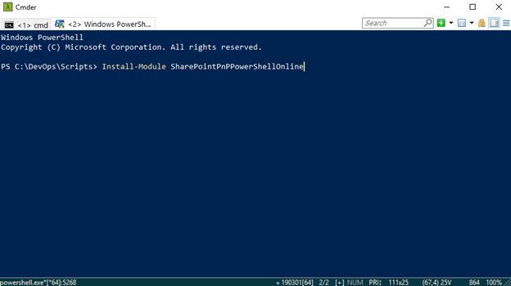

2.    Type “**A**” and press enter

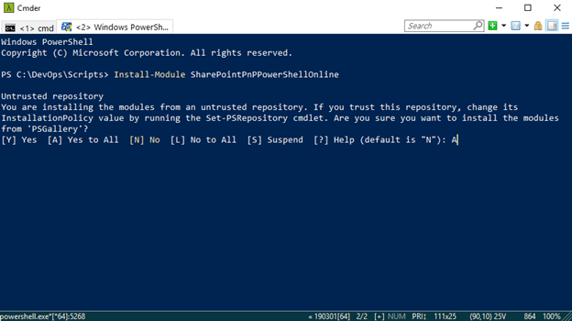

And there you go, easy as that the **SharePoint Online PnP Modules** is now installed. Next let’s check what version and maybe look around a little 😊

**Check Version Installed**

Next let’s check the version of SharePoint Online Pnp PowerShell installed

3.    Type the following and press enter:

*Get-InstalledModule -Name SharePointPnPPowerShellOnline | select Name,Version*

**Parameters**

*-Name* - Specifies an array of names of modules to get.

*-AllVersions* - Indicates that you want to get all available versions of a module.

Finally, once we retrieve the specified **Module(s)** we can then with the pipe command “**|**” select the **name** and **version** to output to the console display.

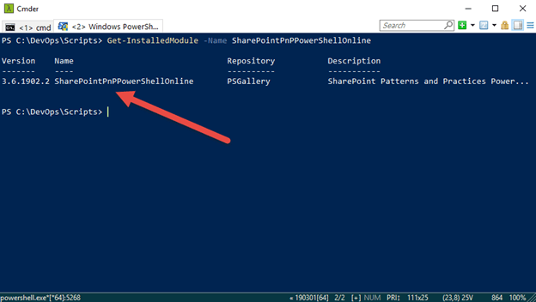

Validate SharePoint Online PnP Connection

Now in order to use the installed Module you first need to connect to your tenant, and to do that we use the following PnP command to connect to a SharePoint site.

4.    At the command line enter the following and press Enter:

*Connect-PnPOnline –Url*[*https://[sitename].sharepoint.com*](https://[sitename].sharepoint.com/)*–Credentials (Get-Credential)*

**Parameters**

*-Url* - The Url of the site collection to connect to.

*-Credentials* - Credentials of the user to connect with.

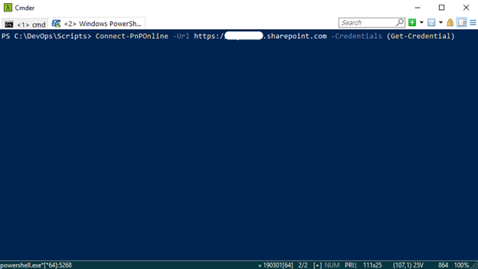

The Windows PowerShell credential request window appears

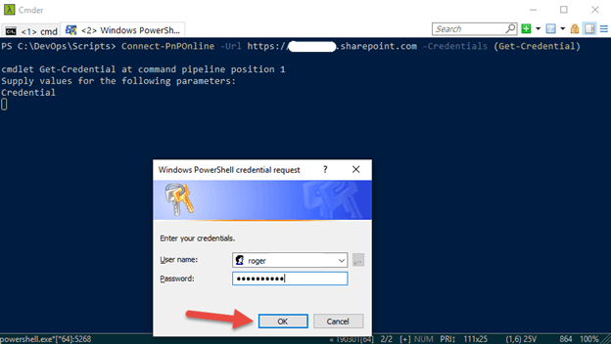

5.    Enter your Microsoft Credentials in the format **[name]@domain.com** and password and click the **OK** button

Your now connected to the **[sitename].sharepoint.com** site specified in the command line below

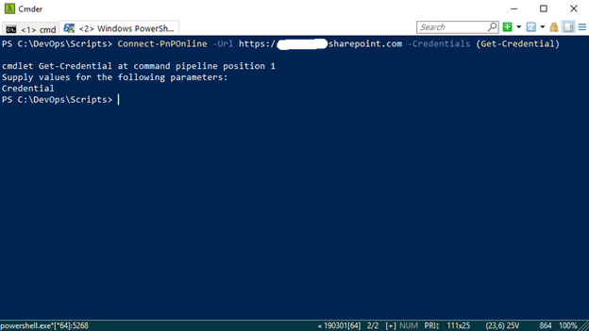

**View all the PnP Cmdlets**

Now let’s take a look at the commands that come with the **SharePointPnPPowerShellOnline** Module.

6.    So, to list all the **PnP** cmdlets type the following command and press enter:

*Get-Command -Module *PnP\**

Now we see below several cmdlets related to **SharePointPnPPowerShellOnline**

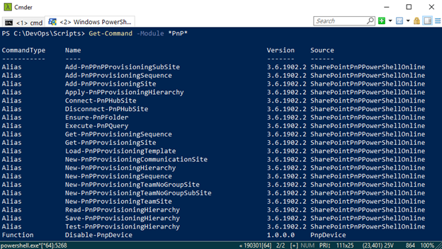

**Help with a Cmdlet**

So now we are connected and looking at all the PnP cmdlets, digging a litter more, let’s see how to use the *Connect-PnPHubsite* cmdlet

This will enable you to learn more about the command and how it can be utilized.

7.    At the command line the following and press enter:

*Get-Help Connect-PnPHubsite*

See the Help information for the Cmdlet *Connect-PnPHubsite* displayed below:

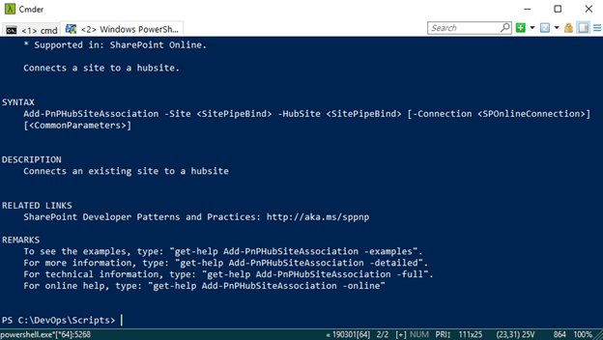

*Get-Help* is your best friend. From understanding what the command is used for, to getting examples of how to use the command is a great way to learn.